Westchester Independent Living Center’s
Parent Training and Information Center & the Autism Project present:
Two Informative Workshops:

The Importance of Advocating for your Special Needs Child
Thursday, November 2, 2017 11:00 AM – 12:30 PM
&
The Importance of Nutrition & your Special Needs Child
Thursday, November 2, 2017 from 12:30 PM – 1:30 PM

Come and Join us learn how to become an effective advocate for your special needs child, and learn practical tips and tools to increase your advocacy skills.

Presenters: Denise Green, Parent Training & Information Center Coordinator
Westchester Independent Living Center

Athena Dent, Vice President of The Autism Project – F.L.O.S Inc.
Practice Nutrition for over 30 years

Location: Yonkers Riverfront Library, 1 Larkin Center, Yonkers, NY 10701, 2nd floor

There is no fee but you must register: Please Click Here to Register
Or RSVP to Denise Green: (845) 228-7457 ext. 1102 or dgreen@putnamils.org or DaQueen Monroe at (914) 979-2194 or info@theautismproject-flos.org
If you need any special accommodations please let us know two weeks in advance.

This workshop is sponsored by Westchester Independent Living Center’s (WILC) Parent training and Information Center (PTIC). WILC is a Core Community Partner funded by a contract with Starbridge Services, Inc. in Rochester, NY through its PTIC grant from the United States Department of Education (H328M110020)

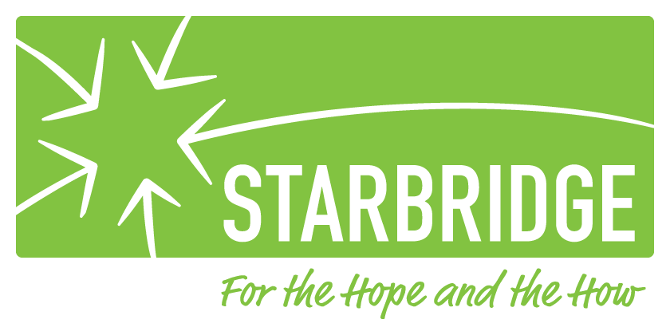
Putnam Independent Living Services
1441 Route 22, Suite 204
Brewster, NY 10509
845.228.7457

Westchester Independent Living Center
10 County Center Road, 2nd Floor
White Plains, NY 10607
914.682.3926

