Parent to Parent of NYS and Westchester & Putnam Independent Living Centers
Family Empowerment Advocacy Series

January 3, 2018

Dear Interested Applicant,

Parent to Parent of NYS and Westchester & Putnam Independent Living Centers are accepting applications from parents, grandparents and guardians of individuals with disabilities to participate in our Family Empowerment Advocacy Series. This series is offered once per year. This series prepares parents, grandparents and guardians of children with disabilities to better advocate within the education system for their own children and as a volunteer to assist other families. The training includes information about the special education process, including the laws, regulations and policies related to students with disabilities. The training aims to improve communication and develop effective advocacy skills.

Participants are selected through an application process and must reside in one of the following counties: Albany, Columbia, Dutchess, Fulton, Greene, Montgomery, Orange, Putnam, Rensselaer, Rockland, Saratoga, Schenectady, Schoharie, Sullivan, Ulster, Warren, Washington and Westchester. There are no fees; however, participants are expected to attend all training sessions in person and webinars to meet the requirements listed in this letter. Accepted applicants are expected to be willing to educate families residing in their county. Graduates of the program may be asked to assist up to three families over the course of the year. Examples of assistance include talking to another parent, grandparent or guardian about education advocacy, assist with problem solving or trouble shooting about their child’s education, or helping a parent, grandparent or guardian learn about special education process. It is not an expectation that graduates attend CSE meetings. Additionally, graduates are asked to participate in occasional surveys and report on your advocacy efforts with other families on a monthly or quarterly basis.

The Family Empowerment Advocacy Series is a 25 hour program conducted via both in-person workshop sessions and webinars. There will be 3 mandatory in-person sessions (each session being 5.50 hours) and 3 mandatory 1 -1 ½ hour webinars (offered day or evening…your choice). Some sessions will require minimal homework. Interested individuals who do not have access to a computer and/or the internet to participate in webinars should contact Tina Beauparlant at (518) 381-4350 x 22 or (800) 305-8817 to discuss available options.

Please see the attachment with an outline of all in person & webinar sessions.
In-person training sessions will take place in 2 different locations connected by way of video conferencing:

Capital District DDSO (Building 3, Room 2) at 500 Balltown Road, Schenectady, NY 12304
Hudson Valley DDSO (Conference room A) 220 White Plains Rd Tarrytown, NY 10591
Interested participants can register on line by clicking HERE
or
Mail, e-mail or fax their completed application, with cover sheet to:
Tina Beauparlant: tbeauparlant@ptopnys.org or Fax (518) 393-9607 or
Denise Green: dgreen@putnamils.org or Fax (845) 228-7460

Applications must be received by February 12, 2018. Participants will be selected based on the quality of their application and ability to serve families in areas of need. Applicants who are selected will receive a confirmation call on February 16, 2018.

If you have questions about the application or the Family Empowerment Advocacy Series, please contact:
Tina Beauparlant at Parent to Parent of NYS, tbeauparlant@ptopnys.org, (518) 381-4350, x22 or (800) 305-8817 or
Denise Green at Westchester and Putnam Independent Living Centers, dgreen@putnamils.org or 845-228-7457, x1102

Sincerely,

Tina Beauparlant Trish Washburn
Regional Program Manager / Education Specialist Education Specialist

Denise Green Becky Coles
Parent Training and Information Parent Training and Information
Center Coordinator Center Specialist

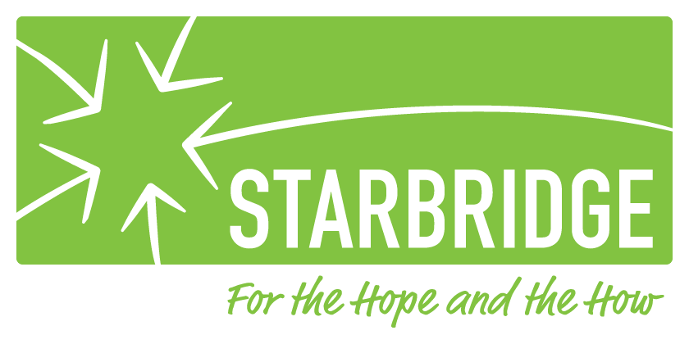

*Funding for this training is provided through the Parent Training and Information Center (PTIC) project administered by STARBRIDGE, Rochester, NY.
Parent to Parent of NYS and Westchester& Putnam Independent Living Centers
Family Empowerment Advocacy Series Application
Application must be received by
February 12, 2018
You can mail, e-mail, fax or register on line
The information on this page of the application is requested by our funding sources and is not
used to discriminate during the application process

(PLEASE PRINT)
Name:________________________________________________________________________
Address:_______________________________________________________________________
City:_________________________________________ Zip:_____________________________
Home Phone:___________________________________ Work:__________________________
Cell:____________________________________ E-mail:________________________________
County:_____________________________________

The area in which you live is: Urban___ Rural___ Suburban___

Ethnicity
Hispanic or Latino _______ Not Hispanic or Latino _______ Undisclosed _______

Race
Caucasian/White_____ African-American/Black _____ American Indian/Native American/Alaskan Native _____ Asian_____ Native Hawaiian/Pacific Islander _____
Two or more races _____ Undisclosed _____

Does your child have an: IEP _____504 ______
What is your child/children’s classification(s): ________________________________________
Participants must reside in one of the counties served by these offices: Albany, Columbia, Dutchess, Fulton, Greene, Montgomery, Orange, Putnam, Rensselaer, Rockland, Saratoga, Schenectady, Schoharie, Sullivan, Ulster, Warren, Washington and Westchester.
I am:
A parent of _____________________child (ren) with disability. Age(s)_____________________
A grandparent of_________________ child (ren) with disability. Ages(s)___________________
A guardian of ___________________child (ren) with disability. Age(s)_____________________

Please check 2 or 3 major life activities affected by your child’s disability:
Receptive & Expressive Language_______ Intellectual disability______
Learning disability ______ Mobility _______Medical _______ Self Care_______ Other______

What services are you or your family member receiving? (i.e. School, Respite, Medicaid Service Coordination, day or residential habilitation):
Education ____ Respite ____ Service coordination ____ Day Hab ___ Residential Hab ____
Individualized Service ____ Employment ____ Job Coach ____ 504______ Other ____

What interests you in this program?
Reputation of the program___ Interest in Advocacy ___ Family members/friends previously attended____ Networking opportunities ____ Learn to assist/advocate for my child and others____ other _____
Comments (Mandatory)__________________________________________________________
______________________________________________________________________________
______________________________________________________________________________

Why are you a good candidate for the program?
I want to learn to be a strong advocate____ I want to be part of a network of advocate’s _____
Other ____
Comment (Mandatory)_________________________________________________________
____________________________________________________________________________

What experience have you had in advocating for people with disabilities?
Personal with my child ____ Personal with friends, neighbors, other parents____
Systemic with other groups and organizations____

Areas of Experience? Advocacy____ Community Inclusion ____ Residential/Housing Option ____ Educational Issues ____ Employment Issues ____ Guardianship & Alternatives ___ Individualized Services ____ SSI/SSDI ____ Transition ____ Other ____
Comments: __________________________________________________________________
____________________________________________________________________________
____________________________________________________________________________

Do you belong to any committees or organizations?
I do not belong to any committees or organizations ____ Community groups ____ School groups (i.e. SEPTA/SEPTO or PTA/PTO) ____ Parent groups ____ Disability-specific groups ____ Faith-based organization ____
Comment (Mandatory) __________________________________________________________
_____________________________________________________________________________
_____________________________________________________________________________

If you are accepted into the Family Empowerment Advocacy Series, how would you use this information to help people with disabilities?
Join a committee or organization related to disability ____
Write letters/visit/educate policymakers _____
Continue my learning by participating in other training/ conferences ____
Educate others ____
Become a voice in my community ____
Become a voice for my child and others ____
Other ____
Are you committed to attending all in-person and webinars sessions? Yes______ No______
If No, please explain: ___________________________________________________________
____________________________________________________________________________
Tina Beauparlant
Parent to Parent of NYS
Family Empowerment Advocacy Series
500 Balltown Rd
Schenectady, NY 12304
(518) 381-4350
Fax: (518) 393-9607
E-mail: tbeauparlant@ptopnys.org

Denise Green
Westchester & Putnam Independent Living Centers
10 County Center Rd, 2nd Floor
White Plains, NY 10607
(845) 228-7457, ext. 1102
Fax: (845) 228-7460
E-Mail: dgreen@putnamils.org

*Funding for this training is provided through the Parent Training and Information Center (PTIC) project administered by STARBRIDGE, Rochester, NY.

