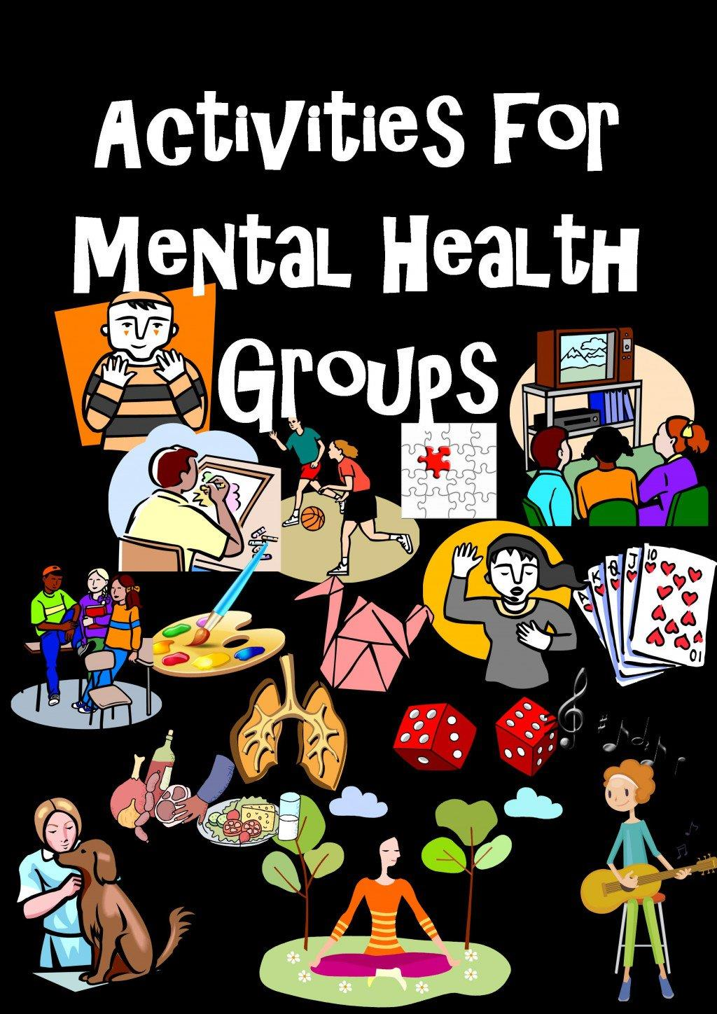
Join us for
Fun Group Activities!
Join us for fun

Where: Westchester Independent Living Center
10 County Center Road – 2nd Floor
White Plains, NY 10607

When: February 14th 2018 from 2:00-4:00pm
and every 2nd Wednesday of the Month

- Social Interactive Games | - Memory Games
- Charades | - Art
- Movies | - Music
- Board Games | - And more
Let’s have fun for a change!

To join us, call Betty: (914) 682-3926 ext. 2109

WILC Serves People with All Disabilities

