Westchester Independent Living Center’s
Parent Training and Information Center & Barnum Financial Group is proud to present: a Webinar on Guardianship

Your daughter is 18, still in school, and has an IEP (Individualized Education Plan) meeting this morning. As you approach the counselor’s office, she turns to you and says, “Mom, I want to do this alone”… what happens?

Your son just turned 18 and you received a call that he slipped and fell while at the market and is in the hospital. You rush to the hospital to see him and ask the staff how he is…what happens?

For some dependents, making day to day decisions can be challenging. Essentially there are two types of decisions that can be made; personal and financial. Some dependents may be able to make both, one or the other, or none at all. When this happens and help is needed, you may want to consider a form of guardianship.

Please join us for a guardianship webinar on Monday February 26th at 12:15. After Registration a separate link will be sent to you so you can connect to the webinar.

There is no fee but you must register: Please Click HERE to Register

Location is wheelchair accessible. If you need any special accommodations please let us know two weeks in advance.

This workshop is sponsored by Westchester Independent Living Center’s (WILC) Parent training and Information Center (PTIC). WILC is a Core Community Partner funded by a contract with Starbridge Services, Inc. in Rochester, NY through its PTIC grant from the United States Department of Education (H328M110020). WILC/PILS serves people with ALL disabilities. If you need special accommodations please let us know two weeks in advance.

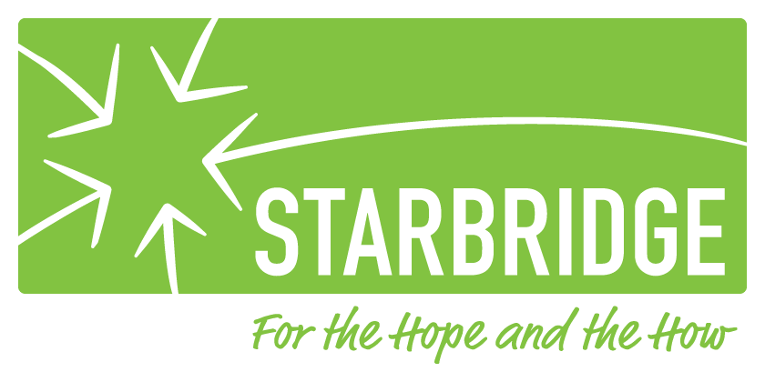
Putnam Independent Living Services
1441 Route 22, Suite 204
Brewster, NY 10509
845.228.7457

Westchester Independent Living Center
10 County Center Road, 2nd Floor
White Plains, NY 10607
914.682.3926

