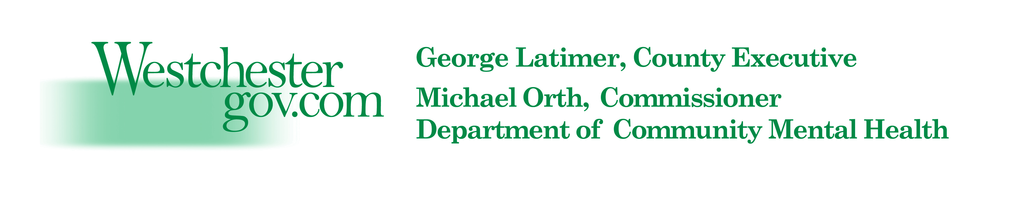
Westchester County Department of Community Mental Health

May Is Mental Health Awareness Month

Events 2019

Please see the list and calendar below for interesting, thought-provoking and important events celebrating May is Mental Health Awareness Month 2019! Thank you to our Westchester agencies who contributed information to this flier to help us spread the word and raise awareness about Mental Health. Feel free to distribute widely.

Sponsor: Westchester County DCMH
Name/Title of Event: May is Mental Health Month Kick-Off Press Conference and Banner
Date: May 1
Time: 2pm
Place: County Executive’s Office
RSVP/Contact Information: Not applicable
Description: County Executive George Latimer will recognize the month with a press conference. A banner, sponsored by NAMI Westchester and the County, will be flown over one of the County buildings.

*****************************************************************************
Sponsor: NAMI Westchester
Name/Title of Event: Ribbon Campaign
Date: Month of May
Place: Throughout Westchester County
RSVP/Contact Information: Call 592-5458 for more information.
Website link: www.namiwestchester.org
Description: Ribbons will be placed on trees and poles in participating towns/cities throughout the County.

*****************************************************************************

Sponsor: NAMI Westchester
Name/Title of Event: Flag Raising - Yonkers
Date: May 1
Time: 12pm
Place: Steps of Yonkers City Hall
RSVP/Contact Information: Call Sharon McCarthy at 592-5458 for more information.
Description: Yonkers City Officials will honor Mental Health Awareness Month with a flag raising ceremony. Join us if you can!

*****************************************************************************

Sponsor: R.I.S.E. Center
Name/Title of Event: Movies In May - Tuesdays and Thursdays
Date/Time: May 2, 7, 9, 14 - 4pm – 6pm
Date/Time: May 16, 21, 23, 28, 30 – 1pm – 3pm
Place: R.I.S.E. Center, 6 Gramatan Avenue, Suite 206, Mount Vernon
RSVP/Contact Information: Call John Lyn 664-3444
Description: Mental Health-themed movies every Tuesday and Thursday for the month of May. Movie list includes (but not limited to) Frankie and Alice, For Colored Girls, Gaslight, Shutter Island, Split, Welcome To Me, and more! Yes, we have snacks….so why not come and visit?

*****************************************************************************

Sponsor: The VA Hudson Valley Health Care System
Name/Title of Event: 2019 Mental Health and Homeless Summit
Date: May 9
Time: 8:30am - 1pm
Place: 41 Castle Point Road, Building 18 – Multipurpose Room, Wappingers Falls
RSVP/Contact Information: Please RSVP via email to Beatrice.Riel@va.gov or by phone at (845) 831-2000, ext. 5408
Description: The purpose of the Summit is to enhance the mental health and well-being of Veterans and their family members through increased collaboration between the VA and the community. This year’s discussions at the Mental Health and Homeless Summit will focus on WHOLE HEALTH. This VA initiative with a focus on Complementary and Integrative Care includes Nutrition, Yoga, Reiki and Whole Health counseling.

*****************************************************************************

Sponsor: Westchester Jewish Community Services
Name/Title of Event: Youth Mental Health First Aid Training
Date: May 14 and May 15
Time: 9am - 1:30pm
Place: Greenburgh Public Library, 300 Tarrytown Road, Elmsford
RSVP/Contact Information: arainone@wjcs.com
Description: This training is open to interested participants. You MUST register and be available for both days of training.

*****************************************************************************
Sponsor: NAMI Westchester
Name/Title of Event: In Our Own Voice Presentation
Date: May 14
Time: 6pm
Place: New York Presbyterian Hospital, 21 Bloomingdale Road, White Plains
RSVP/Contact Information: Call Sharon McCarthy at 592-5458 for more information.
Description: Individuals in recovery share their journey to acceptance and recovery.

Sponsor: Rockland Psychiatric Center
Name/Title of Event: Mt. Vernon Community Advisory Board Annual Dinner Dance
Date: May 16
Time: 7 pm
Place: The Davenport Country Club, New Rochelle

RSVP/Contact Information: Call Sheri Marchi at 665-0200 or Sharon Freeman at 363-1479. Tickets are $50.00. Funds raised go to support programs for people with a mental health diagnosis. This includes trips, Thanksgiving baskets and holiday gifts. If you cannot attend and would like to sponsor a consumer, your tax deductible donation will make a service center member very happy.

*****************************************************************************

Sponsor: Westchester County DCMH, DSS, Family Ties of Westchester and Westchester CCSI
Name/Title of Event: 9th Annual Myra Alfreds Roundtable
Date: May 16th
Time: 9:15am - 12:00pm
Place: The Auditorium at the White Plains Library, 100 Martine Avenue, White Plains
RSVP: https://www.eventbrite.com/e/9th-annual-myra-alfreds-roundtable-20-year-anniversary-celebration-of-westchesters-system-of-care-tickets-59006972443?aff=eac2
Description: 20 Year Anniversary Celebration of Westchester’s System of Care SAMHSA Grant and Recognition Awards Ceremony.

*****************************************************************************

Sponsor: Mental Health Association of Westchester
Name/Title of Event: safeTALK: Suicide Awareness for Everyone
Date: May 16
Time: 9:30am – 12:30pm
Place: Mental Health Association of Westchester, 580 White Plains Road, Tarrytown
RSVP/Contact Information: Email Chuck Rosenow at rosenowc@mhawestchester.org
Fee: $10
Website link: https://www.mhawestchester.org/our-services/education-training
Description: safeTALK is a 3-hour training that teaches participants how to assist individuals who may be having experiences with suicide. During this training, participants will learn how to recognize signs of suicidal thinking, effective ways to start the conversation, and will be provided with information to help connect individuals at risk to useful supports and services. safeTALK is designed for all community members.

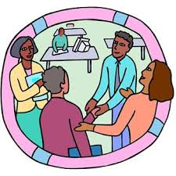
Sponsor: NAMI Westchester
Name/Title of Event: In Our Own Voice Presentation
Date: May 17
Time: 1pm
Place: John C. Hart Memorial Library, 1130 E. Main Street, Shrub Oak
RSVP/Contact Information: Call Sharon McCarthy at 592-5458 for more information.
Description: Individuals in recovery share their journey to acceptance and recovery.

*****************************************************************************

Sponsor: Westchester County Geriatric Mental Health Collaborative
Name/Title of Event: Managing Stress in the Midst of Cultural Chaos
Date: May 17
Time: 10am - 12:15pm
Place: Greenburgh Public Library, 300 Tarrytown Road, Elmsford
RSVP/Contact Information: None required
Website Link: https://greenburghlibrary.libcal.com/ event/4636261?hs=a
Description: Join us for an interdisciplinary panel to discuss the topic of stress management in our current culture. Explore how older adults have coped in the past with environmental stress, how they are coping today and how they experience their world while figuring out ways to manoeuver through new cultural norms. Learn how simple Yoga can help reduce stress. All are welcome – seniors, practitioners, caregivers and the general public. Light refreshments will be served.

*****************************************************************************

Sponsor: NAMI Westchester
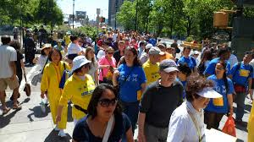
Name/Title of Event: NAMI Walk-Westchester
Date: May 18
Time: 8:30am registration – 9:00am Walk
Place: Rye Town Park, Rye, NY
RSVP/Contact Information: To register go to
www.NAMIWalks.org/Westchester
Or call 592-5458 for more information.
Description: Annual 5K Walk to raise funds and mental
health awareness. Join us for this fun and important event!

May is Mental Health Awareness Month 2019 Events Calendar
Sun | Mon | Tue | Wed | Thu | Fri | Sat
 |  |  | 1 DCMH Press Conference  NAMI Westchester Flag Raising 12pm Yonkers City Hall | 2 R.I.S.E. Center, Movies with Mental Health Themes 4pm, R.I.S.E. Center | 3 | 4
5 | 6 | 7 R.I.S.E. Center, Movie, 4pm, R.I.S.E. Center | 8 | 9 VA MH and Homeless Summit – 8:30am  R.I.S.E. Center, Movies, 4pm, R.I.S.E. Center | 10 | 11
12 | 13 | 14 WJCS Youth MH First Aid Training 9am, Greenburgh Library  R.I.S.E. Center, Movie, 4pm, R.I.S.E. Center  NAMI Westchester In Our Own Voice ,6pm, NYPH | 15WJCS Youth MH First Aid Training 9am, Greenburgh Library | 16 DCMH Myra Alfreds Roundtable, 9:15am, White Plains Public Library  R.I.S.E. Center, Movie, 1pm, R.I.S.E. Center  RPC Mt. Vernon Dinner Dance 7 pm, The Davenport  MHA safeTALK, 9:30am, MHA | 17 Geriatric MH Collaborative 10am, Greenburgh Public Library  NAMI Westchester In Our Own Voice Presentation, 1pm, JC Hart Memorial Library | 18 NAMI Westchester NAMI Walk-Westchester 8:30am, Rye Town Park
19 | 20 | 21  R.I.S.E. Center, Movie, 1pm, R.I.S.E. Center | 22 | 23  R.I.S.E. Center, Movie, 1pm, R.I.S.E. Center | 24 | 25
26 | 27 | 28 R.I.S.E. Center, Movie, 1pm, R.I.S.E. Center | 29 | 30 R.I.S.E. Center, Movie, 1pm, R.I.S.E. Center | 31

