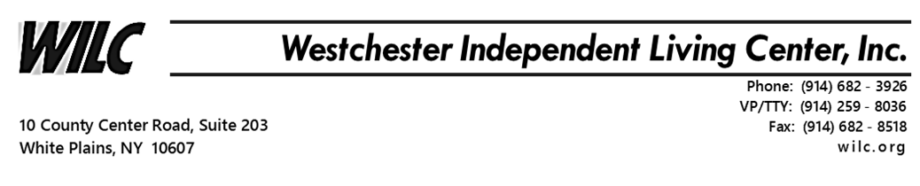

Banking and Savings Fundamentals
The Minority Outreach program is working remotely to provide ongoing service during this time of crisis. Due to COVID-19 and the “Stay Home” social distancing risk factors, we will be conducting our Banking and Savings Fundamentals program via Zoom Meetings.
Minority Outreach Program will hold our Banking and Savings Fundamentals workshop
on Tuesday, 05/12/20 & Wednesday, 05/13/20 from 10am – 12pm.
Wifi or internet service and a smart phone, tablet or desktop computer is required to join. Although a camera is not required, your interaction and participation is needed to complete.
You will learn the basics of banking and savings tips on where and how to manage money. This is a two day workshop for 2 hours each lesson. The first goal is to learn the true value of money and how to gain and maintain financial security. Other long term goals will prepare you for retirement and generational wealth. We will be joined by a guest speaker who is a finance manager of a large banking corporation.
Join WILC’s Minority Outreach Program Banking and Savings Fundamentals Zoom Meeting by registering below.
http://eepurl.com/gYIsY1
For any questions concerning registration email me at JMalloy@wilc.org

Regards,
James Malloy,
Minority Outreach Specialist/Re-entry Programming
Westchester Independent Living Center
10 County Center Rd, 2nd Floor White Plains, NY 10607
Tel. (914) 682-3926 ext. 2102 Fax. (914) 682-8518
JMalloy@wilc.org
Website: www.WILC.org

