Live Workshops

March

hosted by: WILC Minority Outreach
The Minority Outreach program is working remotely to provide ongoing service during this time of crisis. Due to COVID-19 and the “Stay Home” social distancing risk factors, we will be conducting our Social Media Awareness program via Zoom Meetings. MOP Specialist James Malloy will hold our workshop Live.
A touch tone landline, Wifi or internet service and a smart phone, tablet or a desktop computer will be required to join. Although a camera is not required, your interaction and participation is needed to complete. An intake form needs to be filled out to attend the workshop. To register please click or visit - [http://eepurl.com/gYIsY1]
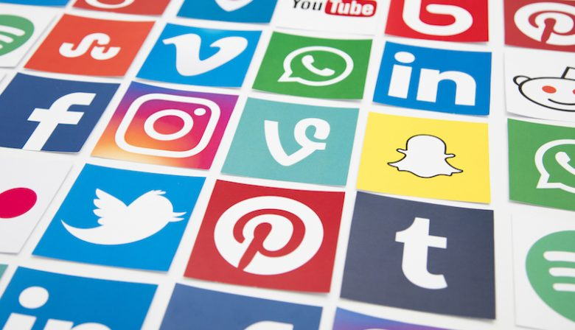

Social Media Awareness - Wednesday, 03/24/2021 from 6pm-8pm
You will learn how to properly use Social Media. This workshop breakdowns the good, the bad and the ugly sides of most social media platforms. Also, how to be aware the fast moving trends of technology.

Below is your zoom sign in link. The room will be open 10 min before workshop is conducted.
[https://us02web.zoom.us/j/5136522594]
Regards,
James Malloy,
Minority Outreach Specialist/Re-entry Programming
Westchester Independent Living Center
10 County Center Rd, 2nd Floor White Plains, NY 10607
Tel. (914) 682-3926 ext. 2102 Fax. (914) 682-8518
Jmalloy@wilc.org

